PERSONAL EXPENSE TRACKER APPLICATION

ABSTRACT

“Expense Tracker” is developed to manage the daily expenses in a more efficient and manageable way. By using this application, we can reduce the manual calculations of the daily expenses and keep track of the expenditure. In this application, user can provide his income to calculate his total expenses per day and these results will be stored for each user. The application has the provision to predict the income and expense for the manager. In this application, there are 3 logins such as admin, manager and staff. Admin has the privilege to add, edit, delete manager, add, edit, delete staff, and to get all custom reports. For Manager, the privileges are to add type of expense, verify expense, add type of income, verify income and generate reports. For staff, the privileges are to add and edit expense, income and calculations, and send for verifications.

LITERATURE SURVEY

1] THANAPAL proposed an expense tracker to prevent having to calculate income and expenses, as well as to remind someone to keep their expenses in track and also to add some details on how much money comes from other people and what expenses or payments the user have to make on a given date or month, User have categories in the expenditure tracker such as add expense, monthly expenses, add new expense, see categories of spending, export expenses in a date range, remove export files, and view expenses by category.

2] CHANDINI proposed an expense tracker that will maintain all the expenses record of users and manage them efficiently. The user can choose an expense category and provide additional information such as a photo, a location, and the amount of the expense, among other things. This will save the information to the local database. The user can examine and sort expenses on a weekly, monthly, or annual basis. By utilising this, they reduced the quantity of manual calculations for their expenses and maintain track of their spending. The user can enter his income to compute his total daily expenses, and the data will be saved for each individual user. This tracker could be useful for people who frequently go on trips or to the theatre with their buddies. This tracker will make it easier for them to disburse the bill. This will show the graph in the chosen view.

3] KARIM proposed an expense tracker to create a a system for recording expenses and income that is simple, quick, and easy to use. This project also includes features that will assist the user in maintaining all financial operations, such as a digital automatic diary. So, in order to create a better expense tracking system, they created a project that will greatly benefit the users. Most people are unable to track their expenses and income, resulting in financial difficulties. In this scenario, a daily cost tracker can assist people in tracking their income and expenses on a daily basis, allowing them to live a stress-free life.

USECASE

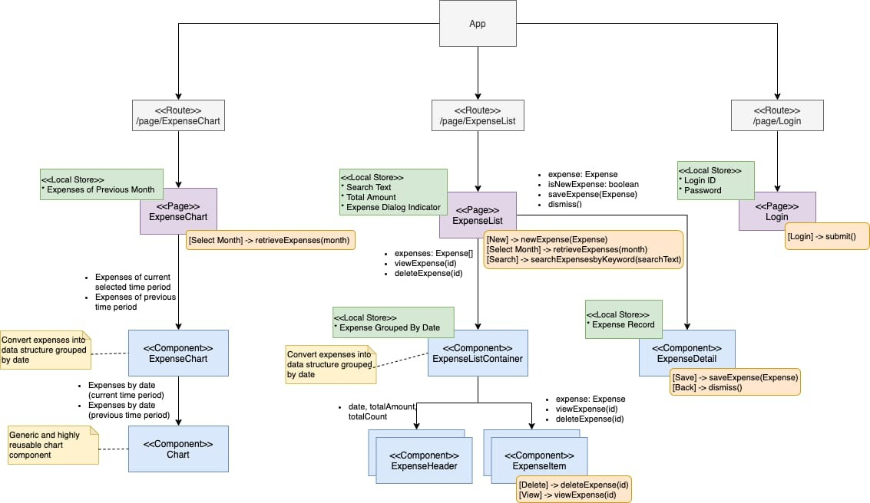

EXISTING SYSTEM

The Expense tracker existing system does not provide the user portable device management level, existing system only used on desktop software so unable to update anywhere expenses done and unable to update the location of the expense details disruptive that the proposed system. In existing, we need to maintain the Excel sheets, CSV files for the user daily, weekly and monthly expenses. In existing, there is no as such complete solution to keep a track of its daily expenses easily. To do so a person as to keep a log in a diary or in a computer system, also all the calculations need to be done by the user which may sometimes results in mistakes leading to losses. The existing system is not user friendly because data is not maintained perfectly. But this project will not have any reminder to remain a person in a specific date, so that is the only drawback in which the remainder is not present. This project will be an unpopulated information because it has some disadvantages by not remind a person for each and every month. But it can used to perform calculation on income and expenses to overcome this problem we propose the new project.

METHODOLOGY

Expense Tracker is going to be a mobile application so that It can be accessed any time required. This application will have a two-tier architecture: first one is the database tier, where all the data and financial data will be stored. Second it will be the user interface which will support the application user communicate with the system and also store Information in the enter the name of the account then that name will be saved in the account tab. If a user wants to delete the particular account, then the user has to click the account name user want to delete. Then that account will be deleted.

VIEW ANALYTICS

The user has pie chart option available for graphical representation. If the user clicks the view analytics it will redirect to the statistics. When the user rotates the phone statistics will initiated and it shows the graphical representation in the form of pie chart. Pie chart it could contains a coloured and percentage view.

FUTURE ENHANCEMENT

The Future Enhancements of the application can be allowed to support in all the upcoming android versions. History can be set to view all the details in the app even if the particular data is deleted from the database. Statistics could be prepared based on the Income, Expense details of the user. Sharing files via Bluetooth, WhatsApp can be allowed. Printing the details of the particular income or expense details can be made. Some of the extra components are like enabling users to register to the application using existing email or social network account, it will synchronize the users profile data to the application.

REFERENCE

[1] http://expense-manager.com/how-expensesoftware/
[2] https://www.splitwise.com/terms
[3] https://code.google.com/p/socialauthandroid/wiki/Facebook
[4] https://code.google.com/p/socialauth-android
[5] Developer.android.com
[6] https://www.appbrain.com/app/expensemanager/com.expensemanager
[7] https://www.xpenditure.com/en?
[8] https://expense-manager.com/how-expense software/

